User login page

When a user opens the website the login page is the first page they are greeted with. The page prompts the user to enter their username and password.

If a user has not registered yet, they can chose to go to the signup page.

If a user forgets their password they can prompt a forget password function which will alert an administrator to reset their password and change their account details accordingly

A user accesses this page from the login page if they have not yet signed up.

This page is a signup page but only works with set user details given by administrators

After signing up the user is prompted to create a new password to replace the preset details

This process will alert an administrator and setup their account in a pending state where an admin will have to approve their account to allow them to log in

This is the home page and where logged in users are directed to as the main page of work.

This page displays briefly the temperature of each sensor on both lines.

The data are separated into groups

This page is accessed from the home page or the historical data page.

This page displays more in depth information about a specific sensor and can show graphs and infographics around the data.

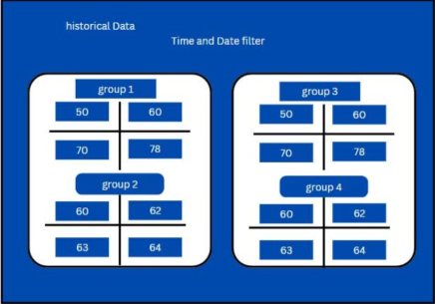

This page is accessed from the navigation bar

This page shows a similar format to the home page but shows the data with a timeline feature. Where the use can filter what data and where in the past they want to view for it.